**MAR ATHANASIUS COLLEGE OF ENGINEERING, KOTHAMANGALAM**

**Initial Project Report**

**DEEP LEARNING-BASED CLASSIFICATION OF DENTAL PATHOLOGIES FROM RADIOGRAPHIC IMAGES**

Done by

**RENJISH K S**

Reg No: MAC23MCA-2046

Under the guidance of

Prof. Manu John

**ABSTRACT**

Topic: **Deep learning-based classification of dental pathologies from radiographic images**

Deep learning has transformed medical imaging, significantly improving diagnostic accuracy. In dentistry, X-ray analysis is crucial but often subjective. This report proposes a NAS Net (Neural Architecture Search Network) deep learning model to enhance dental pathology detection accuracy from radiographic images.

Traditional dental X-ray analysis is prone to subjective interpretation. Deep learning models, especially CNNs, provide consistent, accurate diagnostics. NAS Net automates network configuration, optimizing accuracy and efficiency, addressing traditional methods' limitations.

The reviewed papers employ different neural network methods for dental disease detection. Paper 1 uses a NAS Net-based CNN with a dataset of 245 images, achieving 96.0% accuracy. Paper 2 applies a Hybrid Neural Network (HNN) with 80 images, also reaching 96.0% accuracy, while Paper 3 uses Google Net Inception v3 on 3000 images, achieving 82.0% accuracy and noting challenges with dataset diversity and radiographic settings.

This project develops a NAS Net model for classifying dental pathologies from radiographic images, trained on over 8000 images annotated for cavity, implant, filling, and impacted tooth. Leveraging NAS Net’s optimization, the model aims for high accuracy and generalizability, improving diagnostic support and clinical workflows.

The dataset includes over 8000 radiographic images from various dental clinics, annotated for cavity, implant, filling, and impacted tooth. This diverse dataset ensures robust model performance in real-world settings.

**Dataset link:** https://www.kaggle.com/datasets/imtkaggleteam/dental-radiography

**References:**

1. Abdullah S. AL-Malaise AL-Ghamdi, Mahmoud Ragab, Saad Abdulla AlGhamdi, Amer H. Asseri, Romany F. Mansour, Deepika Koundal, “Detection of Dental Diseases through X‐Ray Images Using Neural Search Architecture Network” Proceedings of the Fifth International Conference on Communication and Electronics Systems (ICCES 2020)
2. L. Megalan Leo and T. Kalapalatha Reddy, “Learning compact and discriminative hybrid neural network for dental caries classification,” Microprocessors and Microsystems, vol. 82, Article ID 103836, 2021
3. JH Lee, DH Kim, SN Jeong, SH Choi, “Detection and diagnosis of dental caries using a deep learning-based convolutional neural network algorithm” Journal of dentistry, 2018

Submitted By: Faculty Guide:

Renjish K S Prof. Manu John

Reg No: MAC23MCA-2046 Associate Professor

2023 – 25 Batch Mace Kothamangalam

**INTRODUCTION**

In the rapidly evolving landscape of dental diagnostics, the efficient identification of dental conditions is pivotal for enhancing patient care and optimizing clinical workflows. Dental disease classification facilitates accurate diagnosis, organizes extensive medical records, and supports targeted treatment strategies. As such, developing a robust and accurate dental disease classification system is essential for both patients and healthcare professionals.

This project seeks to address this need by employing advanced deep learning techniques to classify dental conditions using X-ray images. Specifically, it explores the performance of the NAS Net architecture, renowned for its robust feature extraction capabilities and high accuracy in medical imaging tasks. The evaluation will be based on a comprehensive dataset of over 8000 radiographic images, annotated for four distinct dental conditions: cavity, implant, filling, and impacted tooth.

The dataset comprises high-resolution X-ray images, each carefully labelled and pre-processed to enhance diagnostic accuracy. Key features of interest include edge and contour detection, texture patterns, shape and size analysis, and intensity gradients. These features provide a comprehensive representation of the dental structures, capturing essential characteristics that are critical for accurate disease classification.

Using advanced preprocessing techniques, the images from the dataset will be meticulously prepared and normalized. This preprocessing step is crucial for ensuring the accuracy and reliability of the subsequent deep learning model. The NAS Net architecture will then be applied to this processed data, evaluated for its effectiveness in predicting dental conditions.

Prior studies have demonstrated varying levels of success in medical imaging classification. The NAS Net architecture, with its advanced feature extraction capabilities, has shown promise in handling complex data patterns and achieving high accuracy. The project's focus will be on assessing NAS Net for its precision, computational efficiency, and scalability.

The project will also employ rigorous data augmentation and preprocessing techniques to enhance model robustness and mitigate biases. This includes techniques such as rotation, scaling, and intensity normalization to ensure the model generalizes well to new, unseen data.

By leveraging the NAS Net architecture, the project aims to develop a system that significantly improves the accuracy and efficiency of dental disease classification, thereby enhancing diagnostic capabilities and supporting the broader healthcare industry.

The findings of this project will not only provide insights into the strengths of the NAS Net architecture in dental disease classification but also offer practical recommendations for its application in real-world clinical settings. Ultimately, the goal is to develop a system that significantly improves the accuracy and efficiency of dental disease diagnosis, enhancing patient experiences and supporting dental professionals in delivering high-quality care.

**LITERATURE REVIEW**

**Paper-1**

In the quest to advance diagnostic capabilities within the field of dental health, researchers Abdullah S. AL-Malaise AL-Ghamdi, Mahmoud Ragab, Saad Abdulla AlGhamdi, Amer H. Asseri, Romany F. Mansour, and Deepika Koundal have explored the potential of deep learning technologies. Their study, titled "Detection of Dental Diseases through X‐Ray Images Using Neural Search Architecture Network," was presented at the Fifth International Conference on Communication and Electronics Systems (ICCES 2020). This research investigates the efficacy of Convolutional Neural Networks (CNNs), specifically employing the NAS Net architecture, to enhance the diagnostic accuracy of dental diseases through the analysis of X-ray images. The following table provides a concise overview of the key aspects of their study, including the area of work, dataset specifics, methodology, algorithm, results, advantages, limitations, and future proposals.

|  |  |
| --- | --- |
| **Title of the paper** | Abdullah S. AL-Malaise AL-Ghamdi, Mahmoud Ragab, Saad Abdulla AlGhamdi, Amer H. Asseri, Romany F. Mansour, Deepika Koundal ”Detection of Dental Diseases through X‐Ray Images Using Neural Search Architecture Network” Proceedings of the Fifth International Conference on Communication and ElectronicsS Systems (ICCES 2020) |
| **Area of Work** | The paper explores the use of deep learning, particularly convolutional neural networks (CNNs), to enhance the diagnostic accuracy of dental diseases bioanalyzing X-ray images. |
| **Dataset** | The dataset, from 116 patients at Noor Medical Imaging Centre, Qom, Iran, includes various dental conditions, from healthy to edentulous. Data augmentation increased the images from 83 to 245. The classification focused on three classes: cavity, filling, and implant. |
| **Methodology/Strategy** | Data augmentation techniques like scaling, rotation, translation, Gaussian blur, and noise enhanced dataset diversity. Preprocessing scaled images and encoded labels numerically, leading to a multi-output model using NAS Net with max-pooling layers, dropout layers, and activation functions |
| **Algorithm** | The primary algorithm used is a NAS Net- based CNN. |
| **Results/Accuracy** | The proposed model achieved an accuracy greater than 96%. |
| **Advantages** | The model demonstrated high accuracy in classifying dental conditions by utilizing advanced deep learning techniques. |
| **Limitation** | Lack of dataset |

**Paper 2**

The paper by L. Megalan Leo and T. Kalapalatha Reddy, titled “Learning compact and discriminative hybrid neural network for dental caries classification,” explores an advanced technique for early detection and classification of dental caries. The study aims to improve diagnostic accuracy and efficiency in dentistry using innovative neural network methods. It utilizes a dataset of 80 images, focusing on preprocessing, segmentation, and feature extraction to enhance detection. The proposed Hybrid Neural Network (HNN) demonstrates a high accuracy of 96.0%, offering advantages over traditional methods but is limited by the small dataset size.

|  |  |
| --- | --- |
| **Title of the paper** | L. Megalan Leo and T. Kalapalatha Reddy, “Learning compact and discriminative hybrid neural network for dental caries classification,” Microprocessors and Microsystems, vol. 82, Article ID 103836, 2021 |
| **Area of Work** | The paper focuses on the development of a technique for the early detection and classification of dental caries. The goal is to enhance diagnostic accuracy and efficiency in the dental field by utilizing advanced neural network methodologies. |
| **Dataset** | The dataset, collected from the work by Ching et al. [18] and available on the website wwwo.ntust.edu.tw/~cweiwang , comprises 80 images: 40 for training and 40 for testing, with each image featuring six or more teeth. |
| **Methodology/Strategy** | The methodology of the study involves several key steps, starting with pre-processing where noise is removed using a selective median filter, and the images are converted into grayscale. The images are then segmented using a thresholding technique to identify cavity regions. Following segmentation, features such as shape, size, and density are extracted from the images |
| **Algorithm** | The core algorithm employed in this study is the Hybrid Neural Network (HNN), which combines the strengths of both ANN and DNN. |
| **Results/Accuracy** | The deep learning model achieved a mean accuracy of 96.0%. |
| **Advantages** | The main advantages of the proposed technique include its high accuracy and efficient processing time compared to traditional techniques like Convolutional Neural Networks (CNNs) and multilayer perceptron neural networks |
| **Limitations** | While the study reports promising results, potential limitations include the small size of the dataset used for training and testing, which could lead to overfitting |

**Paper 3**

The paper by JH Lee et al., titled “Detection and diagnosis of dental caries using a deep learning-based convolutional neural network algorithm,” investigates the use of CNNs for detecting and diagnosing dental caries. Utilizing a dataset of 3000 periapical radiographic images, the study employs a pre-trained Google Net Inception v3 CNN for preprocessing and transfer learning. The results reveal high accuracy in detecting dental caries, with the CNN demonstrating notable efficiency and accuracy. However, the study acknowledges challenges such as anatomical factors and the need for validation with more diverse datasets.

|  |  |
| --- | --- |
| **Title of the paper** | JH Lee, DH Kim, SN Jeong, SH Choi, “Detection and diagnosis of dental caries using a deep learning-based convolutional neural network algorithm” Journal of dentistry, 2018 |
| **Area of Work** | The paper focuses on the detection and diagnosis of dental caries using a deep learning-based convolutional neural network (CNN). |
| **Dataset** | A total of 3000 periapical radiographic images were used, divided into training and validation datasets (2400 images, 80%) and a test dataset (600 images, 20%). The images were labeled as dental caries or non-dental caries by board-certified dentists. |
| **Methodology/Strategy** | The images were resized, converted to JPEG, and augmented with rotations, shifts, zooms, and flips. A pre-trained GoogLeNet Inception v3 CNN with 22 layers, inception modules, and auxiliary classifiers was used for preprocessing and transfer learning. |
| **Algorithm** | The paper employs the Google Net Inception v3 convolutional neural network (CNN) architecture, known for its performance in image detection, classification, and segmentation. |
| **Results/Accuracy** | * Premolars: 89.0% * Molars: 88.0% * Premolars and Molars Combined: 82.0% |
| **Advantages** | The study highlights the potential of CNN algorithms to provide fast and accurate detection and diagnosis of dental caries. The deep learning architecture demonstrated significant accuracy and efficiency, supporting its use in clinical dental practice. |
| **Limitations** | The study notes that diagnosing early-stage dental caries with radiographs is challenging due to anatomical factors and variability in clinician experience and radiographic settings. It also emphasizes that the algorithm's performance is limited to the dataset used and requires validation with diverse datasets. |

**LITERATURE SUMMARY**

|  |  |  |  |  |
| --- | --- | --- | --- | --- |
|  | **TITLE** | **DATASET** | **ALGORITHM** | **ACCURACY** |
| **PAPER 1** | Abdullah S. AL-Malaise AL-Ghamdi, Mahmoud Ragab, Saad Abdulla AlGhamdi, Amer H. Asseri, Romany F. Mansour, Deepika Koundal ”Detection of Dental Diseases through X‐Ray Images Using Neural Search Architecture Network” Proceedings of the Fifth International Conference on Communication and ElectronicsS Systems (ICCES 2020) | The dataset, from 116 patients at Noor Medical Imaging Centre, Qom, Iran, includes various dental conditions, from healthy to edentulous. Data augmentation increased the images from 83 to 245. The classification focused on three classes: cavity, filling, and implant. | The primary algorithm used is a NAS Net- based CNN. | 96.0% |
| **PAPER 2** | L. Megalan Leo and T. Kalapalatha Reddy, “Learning compact and discriminative hybrid neural network for dental caries classification,” Microprocessors and Microsystems, vol. 82, Article ID 103836, 2021 | The dataset, collected from the work by Ching et al. [18] and available on the website wwwo.ntust.edu.tw/~cweiwang, comprises 80 images | The core algorithm employed in this study is the Hybrid Neural Network (HNN), which combines the strengths of both ANN and DNN. | 96.0% |
| **PAPER 3** | JH Lee, DH Kim, SN Jeong, SH Choi, “Detection and diagnosis of dental caries using a deep learning-based convolutional neural network algorithm” Journal of dentistry, 2018 | A total of 3000 periapical radiographic images were used, divided into training and validation datasets (2400 images, 80%) and a test dataset (600 images, 20%). | The paper employs the Google Net Inception v3 convolutional neural network (CNN) architecture, known for its performance in image detection, classification, and segmentation. | 82.0% |

The reviewed papers present diverse approaches f or detecting and diagnosing dental diseases using advanced neural network architectures.

Paper 1 by Abdullah S. AL-Malaise AL-Ghamdi et al. focuses on using a NAS Net-based CNN to analyze X-ray images from 116 patients at Noor Medical Imaging Centre. This study, which included data augmentation to increase the dataset from 83 to 245 images, demonstrated a high accuracy of 96.0% in classifying dental conditions into categories such as cavity, filling, and implant. The use of Neural Architecture Search (NAS) highlights the potential of optimizing CNN architectures for precise dental disease detection.

Paper 2 by L. Megalan Leo and T. Kalapalatha Reddy employs a Hybrid Neural Network (HNN) for dental caries classification. Utilizing a dataset of 80 images, the HNN combines the strengths of Artificial Neural Networks (ANN) and Deep Neural Networks (DNN) to achieve a diagnostic accuracy of 96.0%. This paper underscores the effectiveness of hybrid neural network approaches in enhancing classification performance, making significant strides in the accuracy and efficiency of dental caries detection.

Paper 3 by JH Lee et al. applies the Google Net Inception v3 CNN architecture to analyse 3000 periapical radiographic images, divided into training, validation, and test datasets. Although the study achieved an accuracy of 82.0%, it reveals the challenges associated with detecting dental caries, particularly early-stage conditions. The limitations noted include variability in radiographic settings and clinician experience, suggesting a need for further validation with more diverse datasets to improve the model's robustness and generalizability.

**PROPOSED MODEL**

Deep Learning-Based Classification of Dental Pathologies from Radiographic Images Building on the findings from the reviewed literature, the proposed project aims to develop an advanced deep learning model using the NAS Net architecture for predicting dental diseases.

The model will be trained on a comprehensive dataset of over 8000 radiographic images, each annotated for four distinct dental conditions: cavity, implant, filling, and impacted tooth.

The cavity class will identify areas of decay in the tooth structure, while the implant class will detect the presence of dental implants.

The filling class will classify regions where dental restorations have been applied, and the impacted tooth class will identify teeth that have not erupted properly or are misaligned.

The primary goal is to leverage the robust feature extraction capabilities of NAS Net to achieve high accuracy and generalizability across diverse patient demographics. The project will include rigorous data augmentation and preprocessing steps to enhance model robustness and mitigate biases.

Additionally, the implementation will focus on optimizing the network architecture for efficient training and inference, making it suitable for practical clinical deployment. The proposed model aims to provide reliable, automated diagnostic support, potentially surpassing traditional methods and assisting dental professionals in making more accurate and timely diagnoses.

**Motivation for NAS Net**

1.Architecture Optimization: NAS Net is designed with Neural Architecture Search (NAS) techniques that optimize the network architecture automatically, leading to highly efficient and effective models.

* 1. Feature Extraction: NAS Net's architecture provides robust feature extraction capabilities, which are crucial for accurately identifying and classifying complex dental conditions from radiographic images.
  2. High Accuracy: NAS Net has demonstrated superior performance in various applications, including image classification and object detection, making it well-suited for achieving high accuracy in diagnosing dental diseases.
  3. Scalability: The model can handle large datasets and complex image features, which is essential given the comprehensive dataset of over 8000 radiographic images.

**Methodology**

1. **Data Collection and Preprocessing:**
   1. Data Collection:
      * The dataset comprises over 8000 radiographic images, annotated for four dental conditions: cavity, implant, filling, and impacted tooth.
      * Images are collected from diverse clinical sources to ensure a wide range of dental conditions and imaging practices.
   2. Preprocessing:
      * Data Augmentation: Techniques such as rotation, scaling, and contrast adjustment are applied to increase dataset diversity and enhance the model's robustness.
      * Image Normalization: Standardize pixel values to a consistent scale, improving convergence during training.
      * Annotation: Each image is labelled according to the specific dental condition it represents, creating a structured dataset for model training.
2. **Model Development:**
   1. Choosing the Algorithm:
      * The Neural Architecture Search Network (NAS Net) is selected based on its ability to automatically optimize network architecture for the specific task of image classification.
   2. Training the Model:
      * The dataset is split into training and validation sets, with 80% of the data used for training and 20% for validation.
      * The NAS Net model is initialized with pre-trained weights and fine-tuned on the dental dataset.
      * Transfer learning techniques are employed to leverage features learned from other datasets.
   3. Validation:
      * The model’s performance is validated using 10-fold cross-validation to ensure robustness and minimize the risk of overfitting.
      * Metrics such as accuracy, precision, recall, and F1-score are calculated to evaluate model performance.
   4. Hyperparameter Tuning:
      * The NAS Net model's hyperparameters, including learning rate, batch size, and number of layers, are fine-tuned using grid search and cross-validation techniques to optimize performance.
3. **Evaluation:**
   1. Perform 10-fold Cross-Validation:
      * This method is used to validate the robustness of the model and prevent overfitting.
   2. Evaluate the Model:
      * The model is evaluated based on key metrics: accuracy, precision, recall, F1- score, and computational efficiency.
      * Comparative analysis with existing models is conducted to assess the improvement in diagnostic accuracy and efficiency.
4. **Prediction Process:**
   1. Input:
      * An unseen radiographic image is input into the system.
   2. Feature Extraction:
      * Features are extracted from the input image using the NAS Net model, leveraging learned filters and features.
   3. Normalization:
      * The extracted features are normalized to match the scale used during model training.
   4. Model Prediction:
      * The normalized feature vector is passed through the NAS Net model to predict the presence of one or more dental conditions (cavity, implant, filling, or impacted tooth).
   5. Class Label Assignment:
      * The model assigns a class label to the input image based on the learned decision boundaries and probability distributions.

**PIPELINE DIAGRAM**

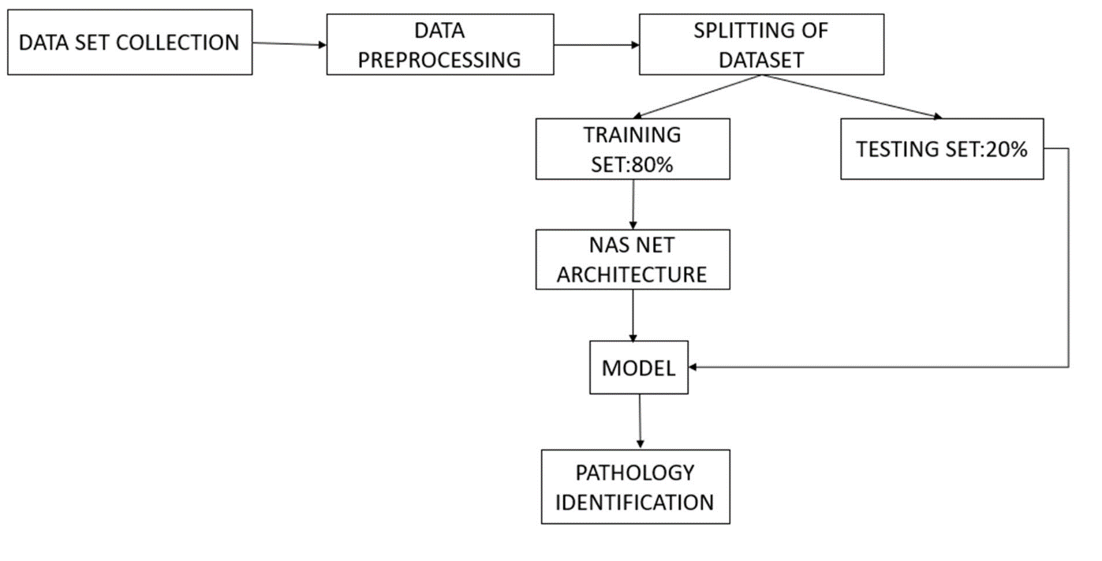

**CONCLUSION**

The selected papers highlight the potential of advanced deep learning architectures in diagnosing dental conditions through radiographic images. Notably, the first paper utilized NAS Net, achieving an impressive accuracy of over 96% for classifying dental conditions such as cavities and implants. This architecture's success is attributed to its optimized feature extraction capabilities, which are essential for handling the complex patterns in dental X-ray images.

In the proposed project, the NAS Net architecture will be employed to develop a robust deep learning model capable of accurately diagnosing four distinct dental conditions: cavity, implant, filling, and impacted tooth. The use of a comprehensive dataset of 8,030 annotated radiographic images will enable the model to generalize across diverse patient demographics. Key to this approach is rigorous data preprocessing and augmentation, ensuring that the model remains unbiased and effective across varying data quality.

The proposed NAS Net-based model aims to provide reliable, automated diagnostic support, potentially surpassing traditional diagnostic methods. This project's focus on architecture optimization, high accuracy, and scalability makes it a promising tool for enhancing clinical decision-making in dental care.

**Dataset Overview**

**DATASET DESCRIPTION**

The dataset comprises 8,030 entries, each corresponding to a dental radiographic image with detailed annotations. These annotations are crucial for identifying and classifying dental conditions, primarily focusing on four categories: cavity, implant, filling, and impacted tooth. The images vary in quality and capture different views, providing a comprehensive resource for training and validating deep learning models in dental diagnosis.

**Source**

The dataset was obtained from a Kaggle repository, which aggregates diverse dental radiographic images from various sources. It ensures a broad representation of cases, enhancing the dataset's robustness and applicability for real-world scenarios.

Dataset link: https://[www.kaggle.com/datasets/imtkaggleteam/dental-radiography](http://www.kaggle.com/datasets/imtkaggleteam/dental-radiography)

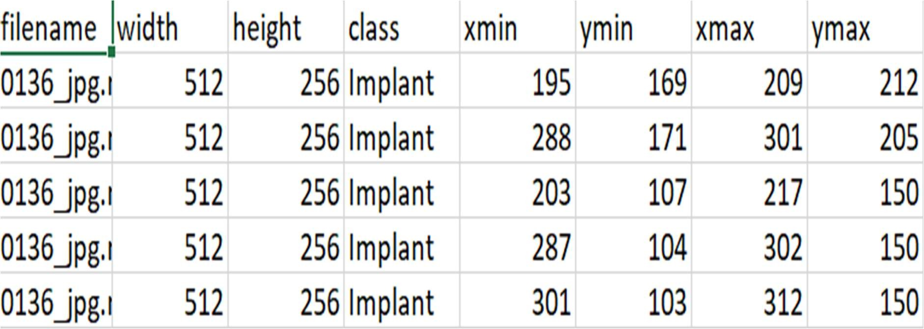

**Features**

Key features extracted from the radiographic images include:

* **Edge Detection:** Identifying the boundaries and contours of dental structures to highlight abnormalities.
* **Texture Analysis:** Analyzing the texture of dental tissues to detect irregular patterns indicative of diseases.
* **Shape Analysis:** Evaluating the shape and alignment of dental elements, aiding in the diagnosis of conditions like impacted teeth.
* **Intensity Histograms:** Assessing the distribution of pixel intensities to identify regions of interest.
* **Region of Interest (ROI) Segmentation:** Focusing on specific parts of the image to enhance diagnostic accuracy.

**Class Labels**

The dataset includes images classified into the following categories:

1. **Cavity:** (576 images) Identifies areas of tooth decay, crucial for early diagnosis and treatment planning.
2. **Implant:** (1,784 images) Detects dental implants used as replacements for missing teeth, assisting in monitoring and follow-up.
3. **Fillings:** (5,242 images) Recognizes dental restorations, helping to assess the state and quality of the fillings.
4. **Impacted Tooth:** (428 images) Identifies teeth that have not erupted properly or are misaligned, often requiring sur